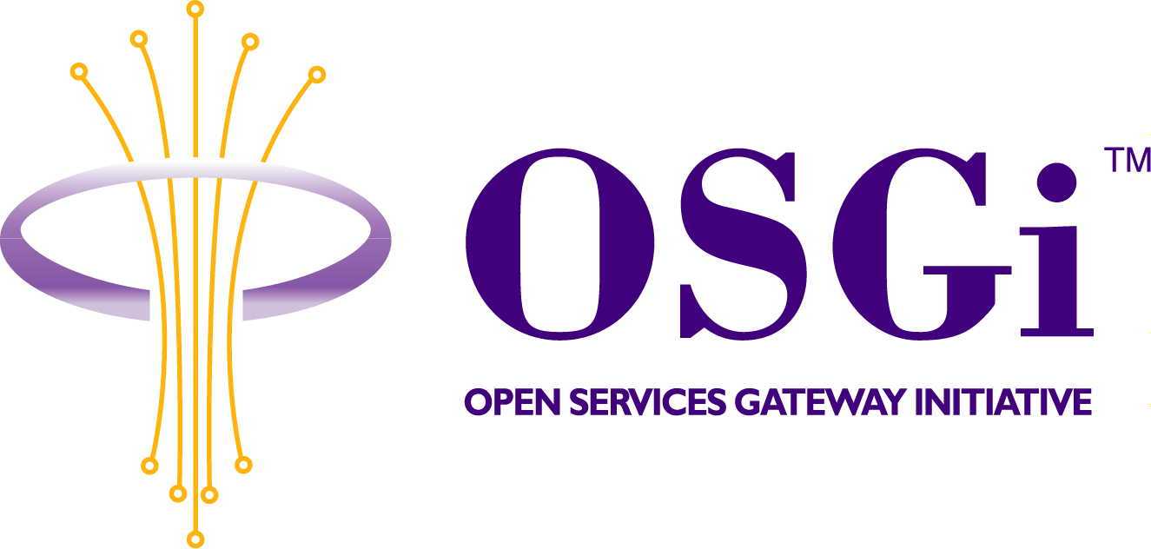
RFP-49: OSGi Service Platform as a UPnP device

Confidential, Draft
12 Pages

Abstract

A local network can contain a number of service platforms. Devices in this network, like appliances, could install bundles in that service platform and provide extra functionalities if they knew the service platform existed. This RFP investigates the requirements that allow these devices to detect the presence of a service platform and manage bundles on that platform.

Document Information

Table of Contents
0 Document Information 2
0.1 Table of Contents 2
0.2 Status 3
0.3 Acknowledgement 3
0.4 Terminology and Document Conventions 3
0.5 Revision History 3
1 Introduction 4
2 Application Domain 5
2.1 Entities 5
2.2 Device Control Protocol 6
2.3 Security 6
2.3.1 JAVA 2 security 6
2.3.2 OSGi Service Platform release 3 security 6
2.3.3 OSGi RFC 73 Permission Admin with Signature 6
2.3.4 UPnP security 6
3 Problem Description 7
3.1 A Connected Device controls an OSGi SP Exporter 7
3.2 Binding a Device Application with its Connected Device 8
3.3 Security 8
4 USE CASES 9
4.1 Application Server Discovery 9
4.2 Connected Device Authentication 9
4.3 Application Server Authentication 9
4.4 Managing life-cycle of Device Application 9
4.5 Filtering Virus 9
4.6 Synchronization between Device Application and Connected Device. 9
5 Requirements 10
6 Document Support 11
6.1 References 11
6.2 Author’s Address 11
6.3 Acronyms and Abbreviations 12
6.4 End of Document 12

Status
This document suggests the following extension to the OSGi Specification. RFP: OSGi Service Platform as UPnP device for the Open Services Gateway Initiative, and requests discussion. Distribution of this document is unlimited within OSGi.

Acknowledgement
.

Terminology and Document Conventions
The key words "MUST", "MUST NOT", "REQUIRED", "SHALL", "SHALL NOT", "SHOULD", "SHOULD NOT", "RECOMMENDED", "NOT RECOMMENDED", "MAY" and "OPTIONAL" in this document are to be interpreted as described.
Source code is shown in this typeface.

Revision History
The last named individual in this history is currently responsible for this document.

Revision | Date | Comments
Initial | July 07, 2003 | Initial Draft  SAMSUNG ELECTRONICS CO., LTD jaeleee@samsung.com
2. | Oct. 3, 2003 | Merged proposed RFP 50 with this RFP 49  Peter Kriens, aQute
3. | Jan. 3, 2004 | Updated  SAMSUNG ELECTRONICS CO., LTD jaeleee@samsung.com
4. | Mar. 23, 2004 | Added security related sections on application domains, problem description, user scenarios, and requirements  Hyun-Gyoo Yook (hgyook@samsung.com)  SAMSUNG ELECTRONICS CO., LTD.
5. | Apr. 22, 2004 | Added description on two major user scenarios at Introduction, added three trust model at section 3.3, and add two more requirements.  Hyun-Gyoo Yook (hgyook@samsung.com)  SAMSUNG ELECTRONICS CO., LTD.
6 | May 4, 2004 | Changed previous requirements (req-4 ..req-8) to more abstract one (req-4), deleted req-11and req-12 and added a scenario that Device Application could be managed by a management agent as well as its Connected Device.  Hyun-Gyoo Yook (hgyook@samsung.com)  SAMSUNG ELECTRONICS CO., LTD.
7 | May 28, 2004 | Apply Peter’s comments  Hyun-Gyoo Yook (hgyook@samsung.com)  SAMSUNG ELECTRONICS CO., LTD

Introduction
Most home devices have severely limited system resources to keep the price as low as possible. That’s why new services for home devices are developed with many restrictions. One of benefits of OSGi service platform for device manufacturers is that it offers standard service execution environment for limited home devices. The service application developers for home devices can support significant functionality without unnecessary restrictions in device’s system resources by off loading the execution to the OSG service platform. For example, a video recorder could offload much of the UI control to an OSGi gateway while only providing the core functionality in the device itself.
In the current environment where technologies are evolving everyday, home devices are easily out-fashioned due to the limited ability of updating embedded functionalities itself. However, home devices could overcome this problem and have benefits of future-proofness by using an OSGi service platform. For example, Tom’s mobile phone has an mp3 song, which is protected by a DRM solution. Tom wants to listen to the song via his living room audio as well. However the living room audio does not support the DRM that the song requires. Tom could enjoy the song via his audio if the audio has OSGi service platform, which gets the audio the appropriate environment to play mp3 files, and mobile phone could deploy the DRM solution to the audio.
This document describes requirements for new service bundle, SP Exporter, that serves bundle lifecycle management functions to a UPnP Control Point device.

Application Domain

Entities

Application Server | In UPnP point of view, it is a UPnP Controlled Device that has a UPnP Application Management Service. In OSGi point of view, it is a service platform that has an OSGi SP Exporter bundle.
SP Exporter | An OSGi bundle that exposes bundle lifecycle management functions to the UPnP world as a UPnP Application Management Service.
Application Management Service | A UPnP Service that serves functions to manage the lifecycle of OSGi bundles. Internally it is the UPnP side interface of SP Exporter.
Connected Device | A UPnP Control Point device that manages the lifecycle of Device Applications by using a UPnP Application Management Service
Device Application | An OSGi bundle installed in an Application Server by a Connected Device.

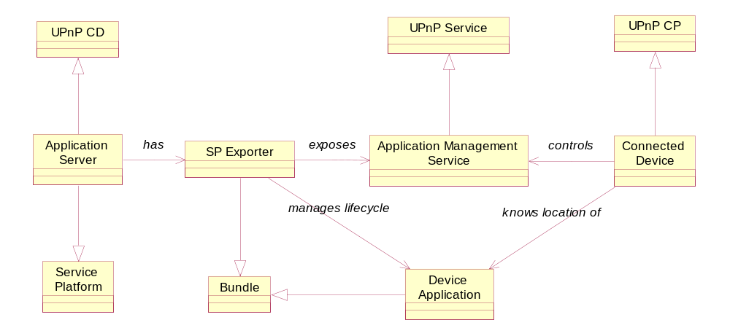

Device Control Protocol
In the home network environment, UPnP™ is becoming a de-facto standard protocol for device control in IP based network. It allows devices to discover each other and to communicate with each other. This RFP assumes UPnP™ as a device discovery and control protocol.

Security

JAVA 2 security
Java supports following three mechanisms for ensuring safety:
- Language design features e.g. bunds checking on arrays, legal type conversions only, no pointer, and so on.
- Access control mechanism that controls what the code can do such as file access, network access and so on. (Java Permission)
- Code signing, whereby code authors can use standard cryptographic algorithms to authenticate Java programming language code. Then, the users of the code can determine exactly who created the code and whether the code has been altered after it was signed.

OSGi Service Platform release 3 security
OSGi service platform supports an access control capability based on Java 2 Permissions. In a platform, a bundle can have a single set of permissions. These permissions are used to verify that a bundle is authorized to execute privileged code. By using Permission Admin, a Management Agent can administrate the permissions of a specific bundle and provide default permissions for all bundles

OSGi RFC 73 Permission Admin with Signature
This RFC proposes a way to do permission administration based on signature. The current OSGi Permission Admin allows assignment of permission based on the bundle location. This mechanism has difficulties to manage permissions of a bundle over untrusted channel such as a bundle on a CD or a bundle from ad-hoc network. To solve this problem, the RFC 73 introduces a new class PermissionQualifier to specify bundle location and signers for permission assignment.

UPnP security
UPnP security specifications support followings:
- Confidential message delivery between devices based on a PKI
- Device to device authentication based on shared secret
- Access control
To support a safe device to device authentication mechanism and access control mechanism, UPnP security introduces a three-tier security model.
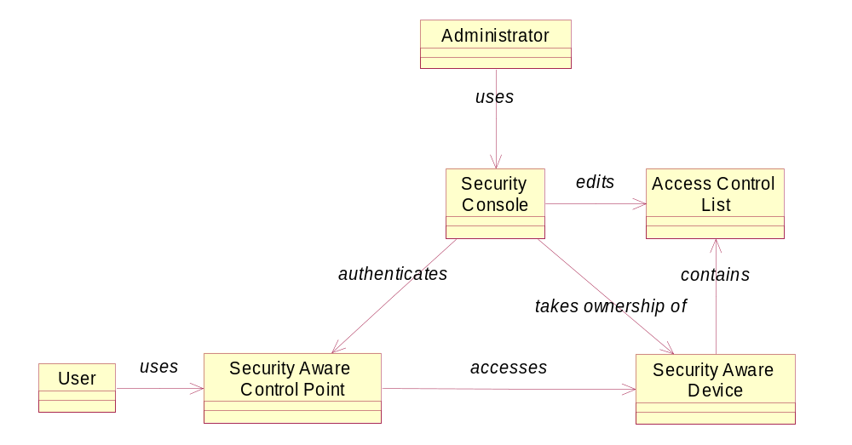
Security Console is a special control point device that is used by an administrator. An administrator who knows the shared secret of a security aware device takes ownership of the device. After that, the administrator edits access control list of the device, which describes access control policy of the administrator. When a user accesses the security aware device by using an un-allowed security aware control point, the security aware device refuses the access.

Problem Description

A Connected Device controls an OSGi SP Exporter
The OSGi service platform provides an execution environment for services that are downloaded over a network. Therefore, resource constrained Connected Devices can use it as an execution environment to process their more demanding bundles. However it requires that Connected Devices must do the following actions to use an OSGi service platform:[Req-1, Req-2]
- Finding an existent Application Server in the network.
- Getting the capabilities (e.g. available services, packages, auxiliaries …) of the Application Server.
- Installing Device Applications in the Application Server.
- Starting the installed Device Application.
- Stopping the active Device Application.
- Cleaning up the installed Device Application.
- Updating the Device Application when necessary.

Binding a Device Application with its Connected Device
Sometimes, an installed Device Application could be closely related with a status of its Connected Device. In the video recorder example in the Introduction section, the UI program of the video recorder would be useless if the video recorder is not connected or is turned off. [Req-5, Req-6]
In this case, the installed Device Application might have following policies
- Stop a Device Application if its Connected Devices are plugged out or turned off.
- Start a Device Application if its Connected Devices are plugged in or turned on.
- Clean up a Device Application if its Connected Device has not been used for a long time

Security
Sometimes, an unknown Connected Device tries to install an unknown bundle. The following are threats that could be happen related to the SP Exporter
- A malicious SP Exporter might intercept a Device Application of a Connected Device.
- Un-allowed Connected Devices might install Device Applications. If we don’t protect this threat, the Application Server could easily become crowded.
- A malicious Device Application, such as virus, might attack the Application Server.
- A malicious Device Application might attack the Connected Device.
To protect these threats, it needs to establish following trusts between 3 entities such as Device Application, Application Server, and Connected Device.
- Trust between Application Server and Connected Device: An owner of an Application Server wants to expose the SP Exporter bundle to allow a Connected Device to install a Device Application. The owner of the Connected Device wants to deliver its Device Application only to a reliable Application Server. [Req-4]
- Trust between Device Application and Application Server: The application provider needs a reliable platform and the SP Exporter would like to install only applications with some guarantees. [Req-3]
- Trust between Device Application and Connected Device: The application should control the device in a correct way, to avoid the risk of damageing it. OSGi Exporter or Application Management Service do not involve in this process.
The trusts are established through authentication process. Required authentication information depends on a business model or situation of relevant entities. In case of the Self-Managed Model, the user has confidence of the Connected Devices and the Application Server because they are physically present. So a device name or an icon should be sufficient. However in the Service Gateway Model, an operator might require more secure information such as a certificate.

USE CASES
Following use cases are based on the DRM scenario at Introduction section.

Application Server Discovery
Tom wants to enjoy the songs via living room audio. When he plugs the mobile phone in the network, the phone finds several Application Servers in the network. The phone retrieves capability of each Application Server such as running services, installed packages and equipped auxiliary devices. Based on the collected information, phone selects the living room audio as the best Application Server [Req-1]

Connected Device Authentication
Tom does not want his living room audio is overflowed by unknown Bundles. So before a Connected Device deploys a new Device Application, it sends user recognizable information to the Application Server. If user allows the deployment, the Connected Device deploys the Device Application. [Req-4]

Application Server Authentication
The song in the Tom’s phone is protected not to copy to untrusted device. To resolve this situation, the living room audio sends a certificate to the mobile phone. If the mobile phone (or operator of the phone) trusts the certificate, the mobile phone installs and starts a DRM agent (a Device Application) on the living room audio device. After this bundle is started, the DRM agent copies the song from the phone and plays it. [Req-4]

Managing life-cycle of Device Application
While listening the song, the Tom remembers that a new version of DRM agent is just released. He stops the DRM agent and updates it with a new version by using a mobile phone or by using a management agent of the audio device. [Req-2]

Filtering Virus
While updating the DRM agent, Tom finds that the new version is infected by virus. So Tom cancels the updating and recovers the old DRM agent. [Req-2, Req-3]

Synchronization between Device Application and Connected Device.
Let’s assume the copyright owner has a policy that the song is playable if and only if the mobile phone is connected. So if Tom plugs out the mobile phone, the living room audio needs to stop the DRM agent. And if user plugs in the mobile phone again, the living room audio needs to restart the DRM agent. [Req-5, Req-6]

Requirements
The OSGi SP Exporter or the Application Management Service must provide:
- The ability to announce the OSGi service platform’s existence in home network.
The SP Exporter bundle must support the UPnP discovery mechanism (SSDP) in order that all home devices can find the Application Server. It must therefore describe itself with UPnP templates to devices. The device description of Application Server must include system information and availability of the resources. According to the device description, Connected Devices can decide whether their Device Applications can run on the platform or not.
- Ability to export bundle lifecycle management functions
The Application Management Service must serve the bundle’s lifecycle management functions (Application Management Service) to Connected Devices. Authorized Connected Devices must be able to manage appropriate bundles’ lifecycle residing on an Application Server. Especially, the management service must provide a function of installation of new bundles from the device or from an Internet location. It must also serve functions to start/stop/update and uninstall the installed bundles.
- Ability to check application integrity.
The SP Exporter bundle must check the application’s integrity before installation. It must guarantee that the downloaded application has not been changed after its release.
- Ability to establish trust between Application Server and Connected Device
SP Exporter and Connected Device must have an ability to establish trust between each other. The way to satisfying this requirement could be various depends on business model.
- Ability to bind between the status of a Connected Device and the status of a Device Application that the device installs
In home network environment, a Connected Device might be suddenly turned off without having a chance to stop its Device Application. In this case, the statuses of the Connected Device and the Device Application could be different. To prevent inconsistency between the Connected Device and the Device Application, the SP Exporter must be able to bind the status of the Connected Device to that of the Device Application.
- Ability to set a binding rule
A binding policy depends on Connected Device or operator. So the SP Exporter must be able to set a binding policy by the Connected Device and/or the operator.

Document Support

References
- UPnP™ Device Architecture http://www.upnp.org/download/UPnPDA10-20000613.htm
- OSGi™ initial provisioning service specification version 1.0
- OSGi™ RFP 73: Permission Admin with Signature
- UPnP™ Security Ceremonies V1.0 http://www.upnp.org/standardizeddcps/security.asp

Author’s Address

Name | Jae shin lee
Company | SAMSUNG ELECTRONICS CO,. LTD
Address | Apkujong Bd., 599-4, shinsa-dong, kangnam-gu, Seoul, Korea
Voice | 82-1-3416-0371
e-mail | jaeleee@samsung.com

Name | Peter Kriens
Company | AQute
Address | 34 Place René Nelli
Voice | +33 467871853
e-mail | Peter.Kriens@aQute.se

Name | Hyun-Gyoo Yook
Company | SAMSUNG ELECTRONICS CO,. LTD
Address | Apkujong Bd., 599-4, shinsa-dong, kangnam-gu, Seoul, Korea
Voice | 82-1-3416-0633
e-mail | hgyook@samsung.com

Acronyms and Abbreviations

SP Exporter | Service Platform Exporter
UPnP | Universal Plug and Play
UPnP CD | UPnP Controlled Device
UPnP CP | UPnP Control Point Device

End of Document

